## **Objectives**

· Explain various ways of conditional rendering

· Explain how to render multiple components

· Define list component

· Explain about keys in React applications

· Explain how to extract components with keys

· Explain React Map, map() function

In this hands-on lab, you will learn how to:

· Implement conditional rendering in React applications

## **Prerequisites**

The following is required to complete this hands-on lab:

· Node.js

· NPM

· Visual Studio Code

## **Notes**

Estimated time to complete this lab: **60 minutes.**

Create a React App named “bloggerapp” in with 3 components.

1. Book Details

2. Blog Details

3. Course Details

Implement this with as many ways possible of Conditional Rendering.

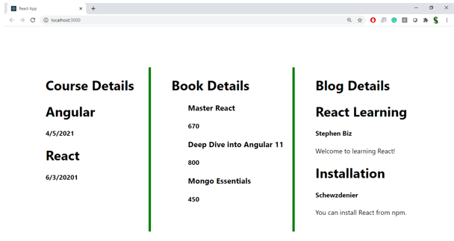

**Hint:**



